Subject: Inflow descriptions
Date: Friday, 19 October 2006

The hydrological data provided in the Centralised Dataset (CDS) includes a number of alternative datasets for several of the different measurement points. These alternatives reflect different assumptions on tributary flows that have been calculated for various historical reasons. This document describes the subset of files that are used by the Electricity Authority for analysis. Any files not mentioned are not used by the Electricity Authority.

Each data set represents a measurement at a particular point on the relevant river system. The datasets include flows into the primary reservoirs such as Lake Pukaki and Lake Taupo. The flow at a given station consists of the flow into these initial reservoirs as well as any incremental flow between any cascading hydro stations down the river chain, plus any additional tributary flow associated with that part of the river system.

The flow on a given river system between hydro stations is a direct product of the simulation model used and any assumptions made, and so is not provided in the CDS. Tributary flow however is calculated as a ratio of the flow at the point the flow was measured, relative to the point that the flow needs to be assessed. These ratio or scale factors are referred to as tributary factors and represent the ratio of net flow at a specific station relative to another. The set currently used by the Electricity Authority are provided in the table on the following page.

The relevant source data listed in the table defines either the incremental tributary flow at that point, or the inflow into the relevant lake or reservoir. Note that as there are several measurement points provided on some of the rivers, there are in consequence several different ways to calculate these flows; the table shows the setup used presently by the Electricity Authority.

Station | Relevant Source data set(s) | Tributary Factor (TF) Scaling (if applicable)
Rangipo | RangipoTPD 92790(2)
Tokaanu | TokaanuTPD 92790(3)
L Waikaremoana | Waikaremoana 3650(1)
Lake Taupo | TaupoTPD 92790(1)
Aratiatia | Arapuni 92724(1) | Arapuni * .064 (Aratiatia TF)
Ohakuri | Arapuni 92724(1) | Arapuni * (0.226 – 0.064) (Ohakuri – Aratiata TF)
Atiamuri | Arapuni 92724(1) | Arapuni * (0.244 -0.226) (Atiamuri – Ohakuri TF)
Whakamaru | Arapuni 92724(1) | Arapuni * (0.48 – 0.244) (Whakamaru – Atiamuri TF)
Maraetai | Arapuni 92724(1) | Arapuni * (0.801 - 0.48) (Maraetai-Whakamaru TF)
Waipapa | Arapuni 92724(1) | Arapuni * (0.835-0.801) (Waipapa – Maraetai TF)
Arapuni | Arapuni 92724(1) | Arapuni * (1- 0.835) (1- Waipapa TF)
Karapiro | Arapuni 92724(1) | Arapuni * (1.178 – 1) (Karapiro TF – 1)
Matahina | Matahina 93254(1)
Mangahao | Mangahao 97502(1)
Patea | Patea 34300(1)
Wheao/Flaxy | Wheao 15462(1)
Kaimai | Kaimai 14130(1)
Cobb | Cobb 97904(2)
Coleridge | Coleridge 97904(1)
Lake Tekapo | Tek_Nat 98770(2)
Tekapo A, B | (Receive flows from upstream only)
Lake Pukaki | Puk_Nat 98770(1)
Lake Ohau | Ohau 98614(3)
Ohau A, B, C | (Receive flows from upstream only)
Benmore | Benmore 98614(4) | Ben trib = Benmore – Ohau
Aviemore | Benmore 98614(4) | Ben_trib * (1.4 -1 ) (Aviemore TF – 1)
Waitaki | Benmore 98614(4) | Ben_trib * (1.617 - 1.4) (Waitaki - Aviemore TF)
Lake Hawea | Hawea 9170(1)
Lake Wanaka | Wanaka 9154(1)
Clyde | Roxburgh 99110(1) | (Roxburgh – Wanaka) * (0.967) (Clyde TF)
Roxburgh | Roxburgh 99110(1) | (Roxburgh – Wanaka) * (1 – 0.967) (1 – Clyde TF)
Te Anau | TeAnau 9570(1)
Manapouri | Manareduced 99552(1)
Branch Scheme | Dip Flat 160114(1)
Waipori | Waipori 174395(1)
Highbank | Highbank 7968(1)

Calculation of Tributary Factors

The tributary factors are calculated as the ratio of flow at the point of interest relative to the point of measurement. This is a concept similar to index numbers. These numbers are used to scale the flow at the point of measurement to represent the incremental tributary flow at the point of interest.

For instance, the tributary factors used by the Electricity Authority for the Waikato stations were derived as ratios of mean flow at each station relative to Arapuni. Thus:

Taupo Discharge 152.4 m3/s (mean flow as measured form Nov 1972 to Mar 2003)

Waipapa Flow 213.7 - 152.4 (Taupo) = 61.6 m3/s
Arapuni Flow 225.8 - 152.4 (Taupo) = 73.4 m3/s

Arapuni TF = 73.4 / 73.4 = 1.0
Waipapa TF = 61.6 / 73.4 = 0.835

These factors will be updated infrequently as measured mean flows change.

New datasets

Fifteen datasets were included in the Spectra Update 6 that were not included in previous versions of the CDS, measuring Wheao, Patea, Highbank, Kaimai, Waipori, Waiau, Ngaruroro, Wairau, Hurunui, Mohaka and Monowai flows. The methodology used by Opus International to generate these datasets is described in ‘Additional Spectra Sites.doc’ and 'Final 5 Sites report.pdf'.
River Chain Mapping

The following diagrams show how the inflow data are currently used in the Electricity Authority’s SDDP models. We emphasize that these models are an approximation to reality and do not fully capture the complexity of the true river systems. There are other ways in which they could be constructed, but this is how they are currently implemented.

Blue arrows indicate external inflows, from the table on page 2. The flow of spill and turbinage is indicated with a black arrow, where these follow the same path; if spill and turbinage proceed in separate directions, then spill is shown with a red arrow and turbinage with a green arrow.

North Island

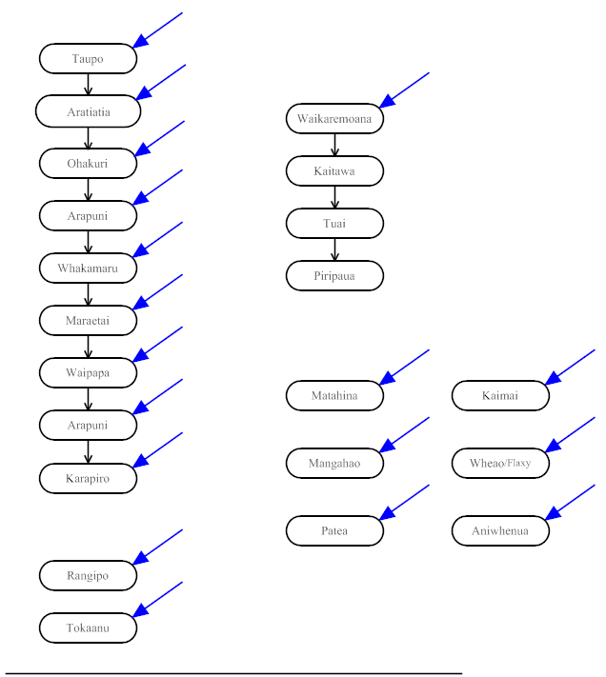

South Island

